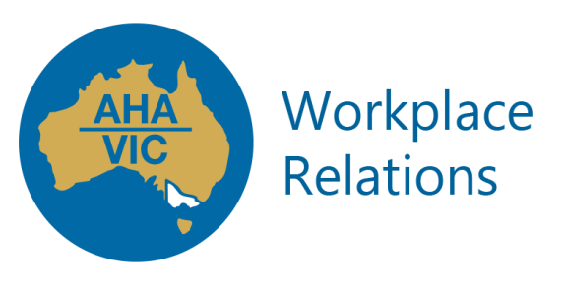

**WORKPLACE RELATIONS**

Workplace Relations is consistently voted the number one member benefit! In an ever changing industrial relations landscape, compliance is a must do for all operators.

Members have access to our talented workplace relations team who provide, support, training and advice on a range of differing topics.

Offering a personalised yet professional service, you’ll feel supported every step of the way!

Hot topics include:

* Understanding the Hospitality Industry (General) Award 2010 (HIGA) & National Employment Standards
* Unfair Dismissals & General Protection Claims
* Alleged underpayment of wages claims
* Representation at Fair Work Commission and Ombudsman matters
* Recruitment and Selection
* Managing probation periods effectively
* On boarding program for new employees
* Learning and Development
* Performance Review and Development
* Occupational Health and Safety (including workplace mental health)
* Workers Compensation
* Immigration Requirements
* Staff Departures (resignations, dismissals, redundancies)
* and a whole lot more!

So if you are a hotel, pub or accommodation provider and need help in this space, give us a call on (03) 9654 7100 today.